

GENERAL RISK ASSESSMENT TEMPLATE

Work area / operation | CB11.10.403 |  | Assessor’s name | Sarah Abadir
Other persons consulted |  |  |  |  | Date of safety assessment |  | 10/09/2023
Subject Coordinator’s Name | Gavin Paul | Lab Supervisor’s Name |  |  |  | Michael Lee

ACTIVITY  - Describe hazardous activities related to the work area or operation. | ASSOCIATED HAZARDS | INHERENT RISK  - Harm that could occur from these hazards if controls fail or are not in place. | EXISTING CONTROL MEASURES | PROPOSED CONTROL MEASURES  - Proposed action to minimise risk to an acceptable level. | TARGET DATE  - To implement proposed controls | RESIDUAL RISK LEVEL (H,M,L)
Electrical cables mishandled/water in environment | Electrical cables exposed or not being used in the way they should be | Electrical shock, personnel injury, work interruption, malfunctioning, corrosion/equipment damage, short circuits | Cables kept under table | Ensure people around are aware that the robot is there | 11/09/2023 | L
Leaving the robot arm unattended | Hazard from moving parts | Injury to personnel, damage to equipment, untrained use of equipment, task interruption | Training, make other alert and spatially aware | Do not leave the robot arm unattended without following appropriate disconnect procedure to ensure it does not unexpectedly move | 11/09/2023 | L
Using inappropriate load on the robot | Loss of control | Tipping or falling, equipment damage, injury to personnel | Regular maintenance, training | Load assessment for whichever robot and objects are being used in conjunction | 11/09/2023 | L
Robot arm moves incorrectly/ Robot colliding with environment (other robot, person, surrounding objects) | Robot collision with object/person/other robot | Injury to personnel, damage to equipment | Clear markings of no-go zones surrounding the robot  Programming validation through simulation | Collision detection systems (Maybe implementable in the future) | Possibly for lab assignment 2 | L
Incorrect manual handling | Manual handling incorrectly | Injury to personnel, damage to equipment, slips trips and falls, | Use mechanical aids, safe work procedures | Eliminate manual handling if possible, or substitute the hazard of manual handling if possible | 11/09/2023 | L
Operating robot when tired or distracted | Delayed response to potential hazards | Injury to personnel or equipment damage | Working in pairs or groups | Planning and ensuring that efficient rest is taken before visiting the lab | 11/09/2023 | L

Approval of assessment | I am satisfied that the residual risk with existing controls is acceptable ☐Yes ☐No  OR  I am satisfied that that the proposed controls will reduce risk to an acceptable level. ☐Yes ☐No | Signature | 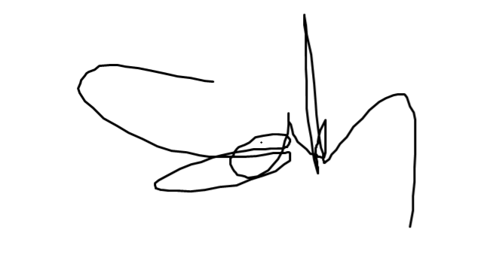 | Date | 10/09/2023

Guidance notes for documenting General Risk Assessments

ACTIVITY
Briefly describe this hazardous work activity - E.g. Operating, Handling, Using … (Include names) of hazardous equipment, substances or materials used, and any quantities and concentrations of substance(s) or reaction products.
ASSOCIATED HAZARDS
Plant & Equipment – noise, vibration, moving parts (crushing, friction, stab, cut, shear), pressure vessels, lifts/hoists/cranes, sharps
Manual Handling – repetitive movements, lifting awkwardly, lifting heavy objects
Work Environment – moving objects, extremes in temperature, isolation, work at height, allergies to animal bedding, dander and fluids, risk of fire/explosion, slippery surfaces/trip hazards
People – potentially violent or volatile clients/interviewees
Communicable Diseases – exposure to bodily fluids/infectious materials, animal bites and scratches,
Environmental – emissions to atmosphere, discharge to soil and water bodies (including stormwater run-off), nuisance noise & odour, poor ventilation/air quality
Radiation (non-ionizing) – including lasers, microwaves or UV light
Electrical – plug-in equipment used in ‘hostile’ work environment, exposed conductors, high voltage equipment
Pathogens – dealings with pathogenic microorganisms such as bacteria, parasites, fungi or viruses
GMOs – dealings with genetically modified organisms
Cytotoxins – carcinogens, mutagens or teratogens
Radiation (ionizing) – Ionizing radiation source such as radioactive substance or radionuclide, or irradiating apparatus
Chemical – hazardous substances, dangerous goods, fumes, dust, compressed gas, hazardous waste
INHERENT RISK
Provide details of the harm that could be caused to people or the environment if something goes wrong.
For example: inhalation of fumes, laceration, injury to back, infection, burns to skin or eyes.
Think about what could happen if controls fail or are not in place.
CONTROL MEASURES
Note the existing and proposed actions to reduce risk to an acceptable level. Apply the “Hierarchy of Controls”, listed below, when deciding the best control measure to apply. Control types closer the top of the list are preferable.
1. Eliminate the hazard. For example: use a different less dangerous piece of equipment, fix faulty machinery, use safer materials or chemicals
2. Isolate the hazard from the people. Separate people from the danger. For example: use shielding, use lifting equipment or trolleys, remove dust or fumes with exhaust system, lock-out machinery.
3. Change the way the job is done. For example: change work practices, provide training, information and signs, develop work procedures.
4. Use personal protective equipment (PPE), noting specific PPE is required for each job. For example: respirator, hearing protection, gloves. Training and information is required for the use of PPE.
RESIDUAL RISK LEVEL (H, M, L)
Estimate risk taking into account the way the activity is run and control measures put in place. The level of risk can be determined by combining consequence and likelihood using the risk matrix from below. Residual risk should be reduced to a level acceptable by management.
CONSEQUENCE OF HARM - This is how bad it will be if something does go wrong e.g. the number of people that could be harmed, the severity of injury.
LIKELIHOOD OF HARM - Chance of harm occurring is affected by the duration of the activity and its frequency; the number of people doing the activity and the level of exposure to the hazard.

